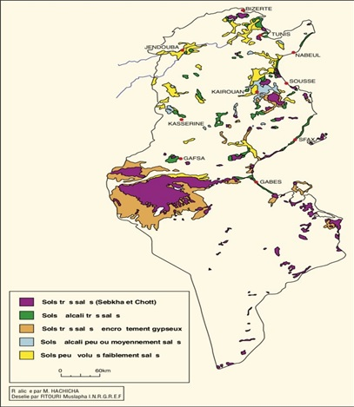

Fig.S1: Distribution cartography of soil with different degree of salinity in Tunisia

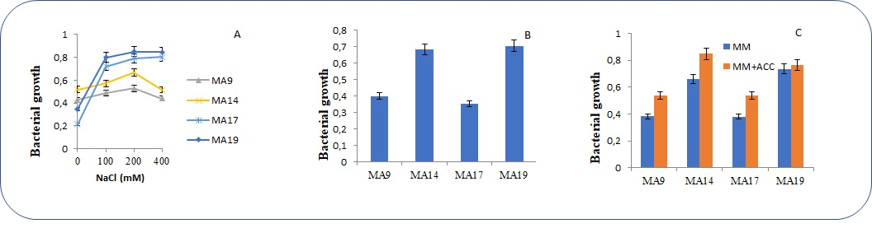
Fig.S2: (A) Salinity tolerance assay of selected strains on LB medium after 48h with different concentration of NaCl; (B) Bacterial growth assay after 7 days of selected bacteria on N free medium (NFMM) and (C)Bacterial growth assay after 7days of selected bacteria on NFMM+ACC as the only available nitrogen source. Error bars show the standard deviation of the mean values of three replicates (P<0.05).

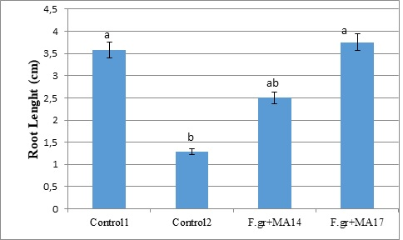
Fig.S3: Effect of Seed biopriming with PGPB’s strains on Fusarium wilt suppression expressed in root length (cm) following inoculation with Fusarium graminarum in seedling explants of durum wheat under controlled culture chamber.
Control1 (not inoculated with any microbe), Control2 (only inoculated with F.graminarum), Treatment1 (inoculated with MA14 and F.graminarum) and Treatment2 (inoculated with MA17 and F.graminarum). Values with the different letter within the same column are significantly different at P < 0.05 according to Duncan’s test.

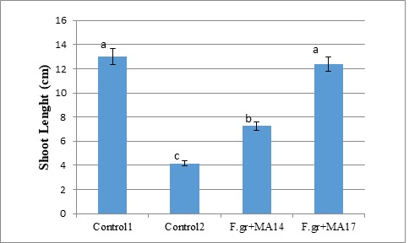
Fig.S4: Effect of Seed biopriming with PGPB’s strains on Fusarium wilt suppression expressed in shoot length (cm) following inoculation with Fusarium graminarum in seedling explants of durum wheat under controlled culture chamber.
Control1 (not inoculated with any microbe), Control2 (only inoculated with F.graminarum), Treatment1 (inoculated with MA14 and F.graminarum) and Treatment2 (inoculated with MA17 and F.graminarum). Values with the different letter within the same column are significantly different at P < 0.05 according to Duncan’s test.
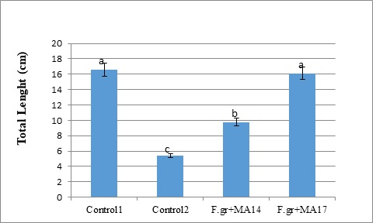
Fig.S5: Effect of Seed biopriming with PGPB’s strains on Fusarium wilt suppression expressed in total length (cm) following inoculation with Fusarium graminarum in seedling explants of durum wheat under controlled culture chamber.
Control1 (not inoculated with any microbe), Control2 (only inoculated with F.graminarum), Treatment1 (inoculated with MA14 and F.graminarum) and Treatment2 (inoculated with MA17 and F.graminarum). Values with the different letter within the same column are significantly different at P < 0.05 according to Duncan’s test.
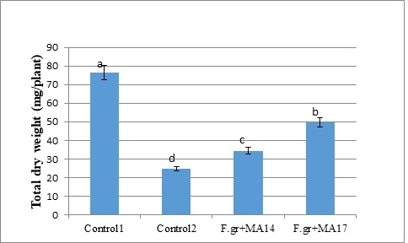
Fig.S6: Effect of Seed biopriming with PGPB’s strains on Fusarium wilt suppression expressed in total dry weight (mg/explant) following inoculation with Fusarium graminarum in seedling explants of durum wheat under controlled culture chamber.
Control1 (not inoculated with any microbe), Control2 (only inoculated with F.graminarum), Treatment1 (inoculated with MA14 and F.graminarum) and Treatment2 (inoculated with MA17 and F.graminarum). Values with the different letter within the same column are significantly different at P < 0.05 according to Duncan’s test.
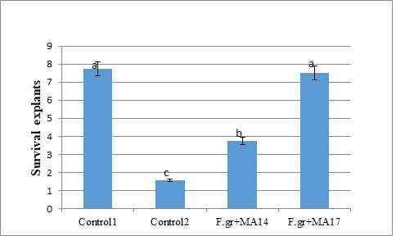
Fig.S7: Effect of Seed biopriming with PGPB’s strains on Fusarium wilt suppression expressed in survival explants following inoculation with Fusarium graminarum in seedling explants of durum wheat under controlled culture chamber.
Control1 (not inoculated with any microbe), Control2 (only inoculated with F.graminarum), Treatment1 (inoculated with MA14 and F.graminarum) and Treatment2 (inoculated with MA17 and F.graminarum). Values with the different letter within the same column are significantly different at P < 0.05 according to Duncan’s test.

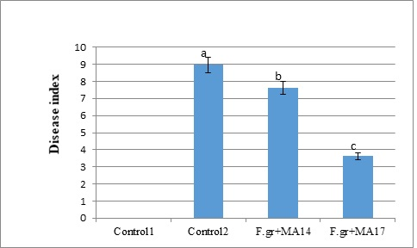
Fig.S8: Effect of Seed biopriming with PGPB’s strains on Fusarium wilt suppression expressed in disease index (DI) following inoculation with Fusarium graminarum in seedling explants of durum wheat under controlled culture chamber.
Control1 (not inoculated with any microbe), Control2 (only inoculated with F.graminarum), Treatment1 (inoculated with MA14 and F.graminarum) and Treatment2 (inoculated with MA17 and F.graminarum). Values with the different letter within the same column are significantly different at P < 0.05 according to Duncan’s test.

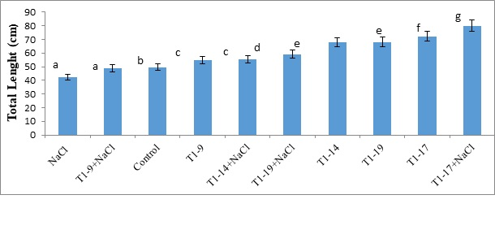
Fig. S9: Effect of Seed biopriming with PGPB’s strains on the total length (cm) of durum wheat plants under different salinity regime.
Bars represent standard error of mean (SEM). Different letters above the error bars indicate significant difference at P B 0.05. Control = no bacterial inoculation under normal conditions; NaCl = no bacterial inoculation under salinized soil; T1 = biopriming seed; 9 = Bacillus pumilus; 14 = Virgibacillus sp.; 17 = Bacillus pumilus: 19 = Bacillus tequilensis.

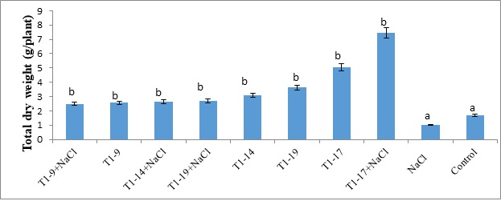

Fig. S10: Effect of Seed biopriming with PGPB’s strains on the total dry weight (g/plant) of durum wheat plants under different salinity regime.
Bars represent standard error of mean (SEM). Different letters above the error bars indicate significant difference at P B 0.05. Control = no bacterial inoculation under normal conditions; NaCl = no bacterial inoculation under salinized soil; T1 = biopriming seed; 9 = Bacillus pumilus; 14 = Virgibacillus sp.; 17 = Bacillus pumilus: 19 = Bacillus tequilensis.

Fig. S11: Effect of Seed biopriming with PGPB’s strains on the root area (cm²) of durum wheat plants under different salinity regime.
Bars represent standard error of mean (SEM). Different letters above the error bars indicate significant difference at P B 0.05. Control = no bacterial inoculation under normal conditions; NaCl = no bacterial inoculation under salinized soil; T1 = biopriming seed; 9 = Bacillus pumilus; 14 = Virgibacillus sp.; 17 = Bacillus pumilus: 19 = Bacillus tequilensis.

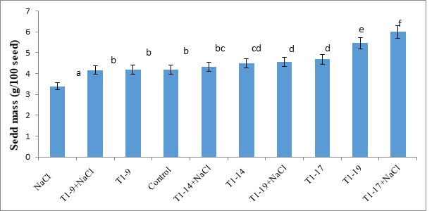
Fig. S12: Effect of Seed biopriming with PGPB’s strains on seed mass (g/100 seed) of durum wheat plants under different salinity regime.
Bars represent standard error of mean (SEM). Different letters above the error bars indicate significant difference at P B 0.05. Control = no bacterial inoculation under normal conditions; NaCl = no bacterial inoculation under salinized soil; T1 = biopriming seed9 = Bacillus pumilus; 14 = Virgibacillus sp.; 17 = Bacillus pumilus: 19 = Bacillus tequilensis.

